Foraging Use of Aleutian Cackling Geese in the Arcata Bottoms, California
By: Steven Jensen, Jennifer Kellerman and Elysia Pina

Abstract:
The Aleutian Cackling goose (Branta hutchinsii leucopareia) is one of the smallest subspecies of Canada goose. Its wintering grounds are mainly contained to Oregon and California, including the Arcata Bottoms. Migrating Aleutian geese feed primarily on fresh grass blade which creates conflict between the geese and farmers in the Arcata Bottoms. With this project, we aim to estimate the abundance of Aleutian geese in the Arcata Bottoms and analyze their forage preferences. We digitized the fields in Arcata bottom to create a map that illustrated the pounds of grass grazed per flock per hectare in each field. We found that two fields provided over 5000 pounds of feed per hectare of land. This information can be used in future management implication to better understand the optimal habitat and plan restoration of public lands accordingly.

Introduction:
Due to the release of foxes by fur traders to the Aleutian islands in the late 1800, the population of Aleutian Cackling geese on the island plummeted exponentially until it was listed on the endangered species act in 1967 ( US Fish and Wildlife). With the extirpation of the foxes on the island, combined with conservation efforts throughout their flyway, the Aleutian has rebounded to an overwhelming size. This overwhelming population has begun to incite anger with cattle and dairy farmers located in the Humboldt Bay area (Figure 1). This anger comes from the geese competing with the cattle for grass. Newly grown grass blades are the primary food source for these birds during their winter and spring migration. Our objective was to estimate the abundance of Aleutian geese in the Arcata Bottoms and analyze their forage preferences.
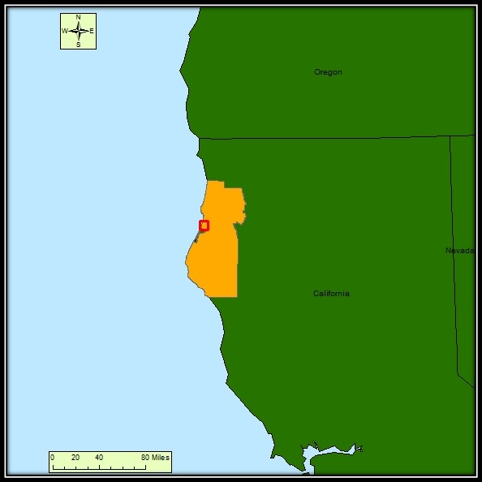
Figure 1.) General study location in Arcata Ca.

Methods:
The first step to creating a map of the pounds of grass grazed by Aleutians per hectare on the fields in Arcata was to download a county outline, roads layer, NAIP, and states layer. The county outline and roads layer was downloaded from the Humboldt County website. The NAIP image was downloaded from the Humboldt State University Lab 4 instructions page. The states layer was pulled from Esri, Inc. web site. Next we created a shapefile and digitized all of the different fields in the Arcata bottoms. The layer was digitized based on a hand drawn map provided by a fellow student who is working on a similar project. The map came from an unknown source however, so we matched the hand drawn map to the NAIP image as best as we could. We added the following fields to the attributes table of the digitized layer: name of field, total number of geese, pounds of grass grazed per flock at each field, and area. The total number of geese and pounds of grass grazed per flock at each field was collected and calculated by Capra, S. P. during their 2015/2016 migration. With this data and our digitized fields layer, we created maps illustrating the impact of Aleutians on individual farms in the Arcata Bottoms.

Results:
A total of 92,676 geese were observed using the field within the study area of the Arcata Bottoms and surrounding area between 2 October 2015 and 26 February 2016. Geese were only found in approximately 30 percent of the study area. Over the course of the study period, the most geese were found in Christie101 (6,025 Aleutians), WA1 (5,422 Aleutians) and CAL_BC3 (5,355 Aleutians, figure 2). The fields providing the most weight differed slightly from amount of geese found within them. Over the entire study it was estimated that 369,945 pounds of grass was grazed. The highest three grazed fields included MS2 (31,843 pounds), CAL_BC3 (22,910 pounds) and WA1 (21,247 pounds, figure 3). Although this data is informative, it does not calculate for the size of the field. In order to account for this, we calculated the pounds grazed per hectare for each field. We found that the highest density of grass grazed came from two fields MS3 (6576 pounds per hectare) and CAL_BC3 (5923 pounds per hectare, figure 4).
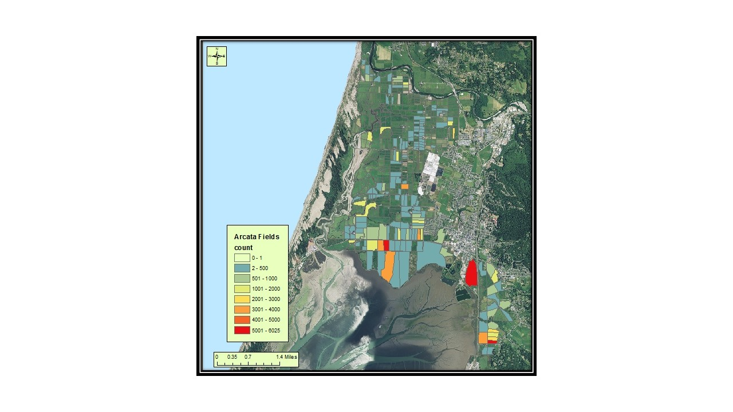
Figure 2. Total counts of Aleutian Cackling geese in
the bottoms and surrounding area of Arcata Ca.

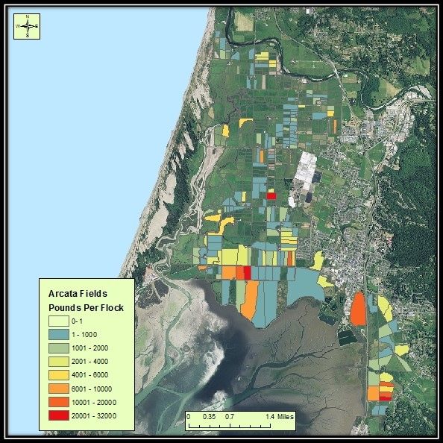
Figure 3. Total pounds of grass grazed by Aleutian
Cackling geese in the bottoms and surrounding area
of Arcata Ca.
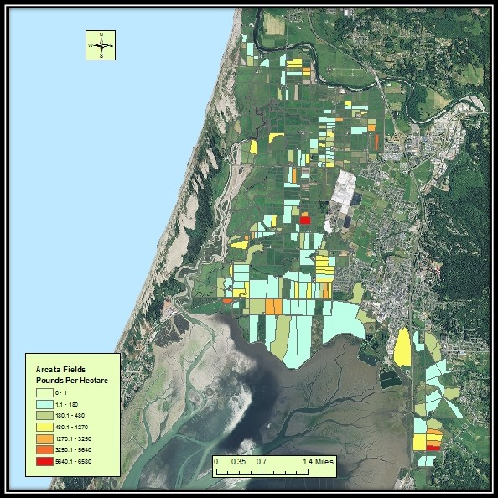
Figure 3. Total pounds of grass grazed per hectare by
Aleutian Cackling geese in the bottoms and surrounding
area of Arcata Ca.

Discussion:
The calculations derived in this analysis are rough estimates. The exact amount of grass being grazed is unknown and error in our digitizing protocol has led to inaccuracies in the areas of each field. However, the results that we found are significant enough to illustrate the fields most heavily impacted by the Aleutians. Gaining an understanding of the diet and feeding habits of these birds provides managers with insight on the optimal foraging habitat for these geese and the ability to provide better resources for the geese. These results show that there is a factor present in these fields that the geese are exploiting. Further studies could be conducted to analyze data in the subsequent year to examine if a pattern arises in the fields being selected. Also, we suggest that further analysis should be conducted within the fields to gain an understanding of the resources that these fields are providing. The discovery of these resources can allow managers to develop optimal habitat on public land that will draw the birds off of private land, thus significantly reducing the competition that currently exists between the birds and the cattle.

Acknowledgements:
We would like to thank Scott Capra for allowing us to use the data that he had gathered along with the equations that he derived. We would also like to thank Jim Graham for the instruction that gave us the knowledge to complete this task. Without these two people none of this would have been possible.

